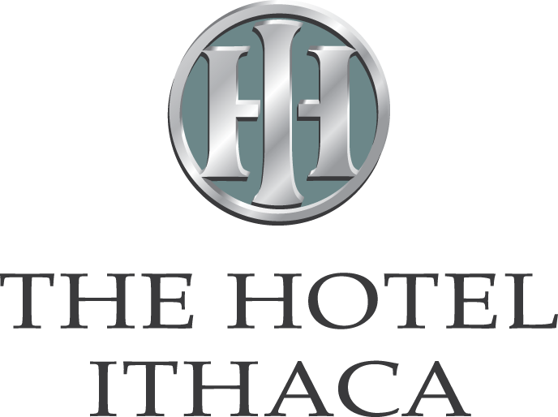

BUTTERMILK FALLS DINNER BUFFET
(35 person minimum)

$44.95

Salad of Mixed Field Greens
Basket of Warm Rolls and Butter
Choice of Seasonal Vegetable

Choice of One Hors D’oeuvre
Vegetable Crudités with Herb Dip
Domestic and Imported Cheese Tray with Assorted Crackers
Fresh Sliced Fruit Tray

Choice of Two
Carved Roast Top Sirloin Au Jus
Oven Roasted Turkey Breast with Cranberry Walnut Dressing
Boneless Breast of Chicken
choice of one sauce Marsala, Tarragon Cream or Piccata
Marinated Pork Loin Caribbean
Virginia Baked Ham with Maple Orange Glaze
Seafood Newburg with Rice
Spinach Stuffed Filet of Sole
Seafood Creole with Rice
Beef Bourguignon

Choice of One
Rice Pilaf, Potatoes Au Gratin, Parsley Buttered, Oven Roasted,
Garlic Parmesan Whipped Potatoes or Whipped Sweet Potatoes

Choice of One
Tortellini Primavera
Penne Pasta with Marinara Sauce
Bowtie Pasta with Pesto

Choice of Dessert
Mixed Berry Tart, Tuxedo Cake, Carrot Cake or
NY Style Cheesecake with Raspberry Sauce

Assorted Sweets Table - $9.95 per person additional

Coffee Service

(PRICES ARE PER PERSON AND DO NOT INCLUDE TAX OR SERVICE CHARGE)

1023

